Low Level Design (view item module)

Project Code | Team 1
Project Name | Ecommerce(Online Shopping)

Prepared/Modified by | Role | Date of Preparation
Amit Agarwal | Software Engineer | 16/12/2013
Reviewed by | Role | Date of Review
Shrikant Sutar | Software Engineer | 17/12/2013
Approved by | Role | Date of Approval
Uma M Ponniamman | Training Manager
Circulation List | amit.agarwal@igate.com, mrunalee.kothari@igate.com, keerthi.parthasarathy@igate.com, nidhi.shetty@igate.com, nikeeta.menon@igate.com, shrikant.sutar@igate.com, bhagyashree.vedpathak@igate.com | Version Number of the template:1.0
Version Number | 1.4

Table of Contents

1. Description Of The Unit 3
2. References 4
3. Dependencies / Assumptions 5
4. Class Diagrams 6
5. Sequence Diagrams 7
6. Design Components 8
6.1 List Of UI Components 8
6.2 List Of Design Classes 8
7. Re-Usable Routines/Components 9
8. Messages 10
9. Configuration Files 11
10. Crud Matrix Table 12
11. Data Mapping Matrix 13
12. Action Flow Matrix 14
13. Stored Procedures 15
14. Program Specification / Pseudo Code 16
REVISION HISTORY OF THE WORK PRODUCT 17

Description Of The Unit

The View Item module is basically used by the visitor/customer of the system, to view the existing product.

On clicking the view button of any products on home page, the visitor/customer will be navigated to the view Item page which shows the description of a particular product where he/she can view complete description of product and buy it.

The view Item page shows the detailed description of the product and also the current stock available of that product. If a visitor clicks on the ‘Add to Cart’ button to buy that product then he/she is navigated to the login page (because any unregistered person is not allowed to buy any item).If a registered customer is logged in and if he/she clicks on the ‘Add to Cart ’ button then the item is added to the cart and the customer can then either continue shopping or can place the order.

References

Reference | Description
Repository reference | https://IGTEBLRSVNTNG.igatecorp.com/svn/oct3_Team1
Class Diagram | /Project Documents/Design Documents/HLD/Class Diagrams
URS | /Project Documents/Requirements/Case Study/Ecommerce-grp1 and grp3.doc
UTP | /Project Documents/Test Plan/UTP/Test Cases/ViewItemModule/UTP_ViewItemModule.xls
DB Design | /Project Documents/Design Documents/HLD/DB Design/E-Commerce_GROUP_DBDESIGN.xls

Dependencies / Assumptions

Assumptions:
Valid details of the product stored in the database.

Class Diagrams

Class Diagram

Sequence Diagrams

Sequence Diagram
NA

Design Components

List Of UI Components

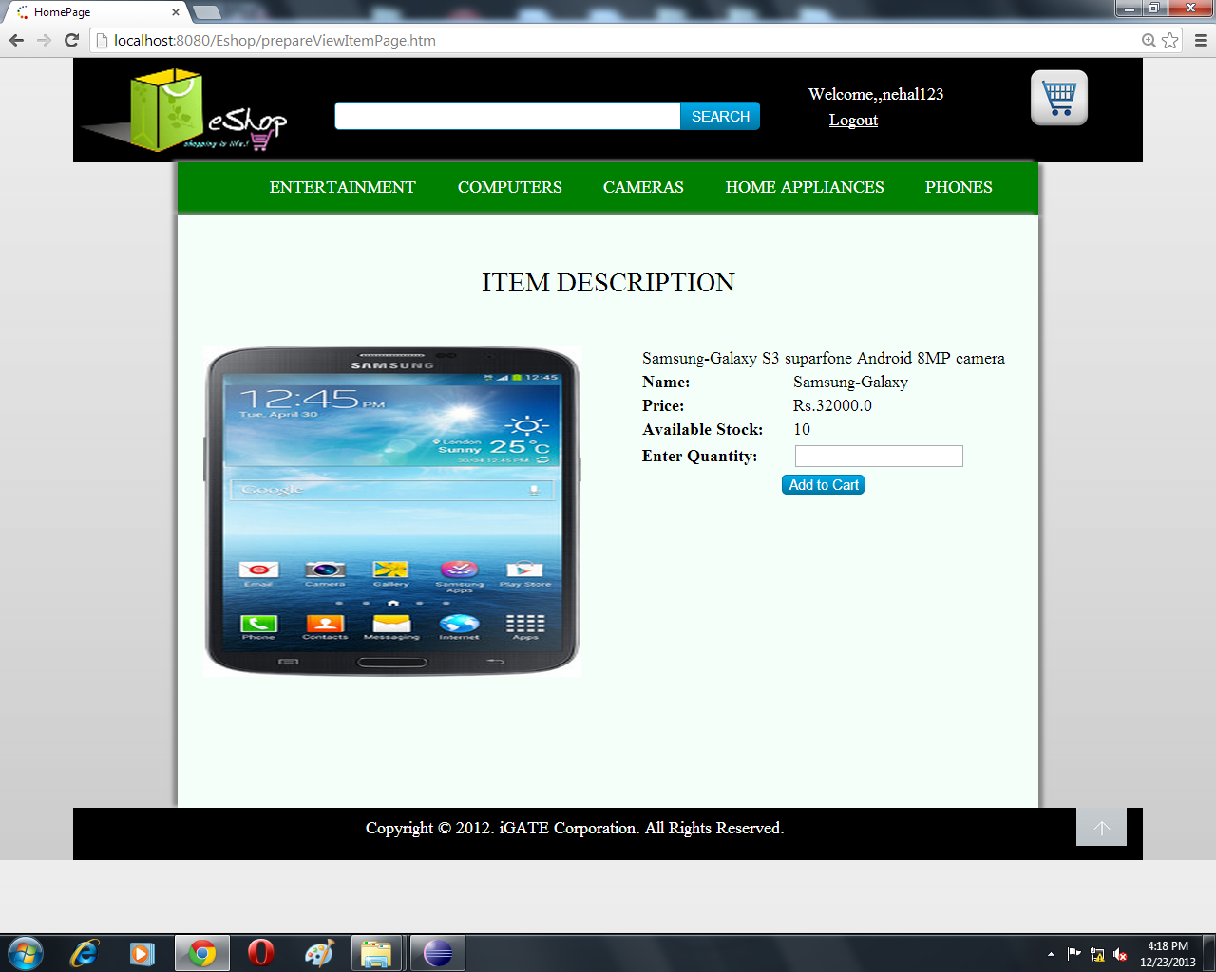

List Of Design Classes
Sr. No. | LLD Name | Class Name | Method Name | Method Description
1 | View Item Module | Product,  ProductImage | Appropriate getters and setters methods | Getters retrieve the property values and setters set the property values
2 | View Item Module | EshopController | public String prepareViewItemPage(@RequestParam(value="productId") String productId,@RequestParam(value="buttonValue") String buttonValue, Model model):String | Get the appropriate product details from the Home Page and set the data into Product and Product Image bean and add these data to the model attribute.  Controller then navigates to the View item page which shows the description of that product.
3 | View Item Module | EshopBOImpl | getProductDetails(String):Product  validateQuantity(int):Boolean | Calls getProductDetails  (String) of EshopDAOImpl class and returns the Product details to controller.  Validate the number of quantity entered by customer for the product with the available stock.  Show appropriate message if quantity exceeds the current stock.
4 | View Item Module | EshopDAOImpl | getProductDetails(String):Product | Retrieves the product details from database and returns the Product Object to EshopBOImpl

Re-Usable Routines/Components

Re-Usable Routines/Components

- CSS files
- Javascript files
- DataAccessException class
- Database properties files
- Logger properties files

Messages

#. | Type | Message Text
M1 | Error | Enter a valid quantity.
M2 | Error | Quantity cannot be empty.

Configuration Files

File Name | Path | Description
oracle.properties | /Development/Source | To configure database connection.
Web.xml | /Development/Source | To configure the bean properties.
Dispatcher-servlet.xml | /Development/Source | To configure the request mapping and view resolver.
Eshop_logger.properties | /Development/Source | To configure the logger.
Eshop_error.properties | /Development/Source | To configure error messages.

Crud Matrix Table

# | Table Name | Create | Read | Update | Delete
1 | Product | N | Y | N | N

Data Mapping Matrix

Sr. No. | Screen Label | Field Source | Field Type | Data Type | Max Length | Data Flow | Mandatory
1 | View | NA | Button | NA | NA | UI | NA
2 | productId | Product. Product_Id | HiddenFiled | Varchar2 | 10 | UI→D  D→UI | Yes
3 | Product Description | Prodcut. Product_Description | Label | Varchar2 | NA | D→UI | Yes
4 | Product Price | Prodcut. Product_Price | Label | Decimal | 8 | D→UI | Yes
5 | Product Name | Prodcut. Product_Name | Label | Varchar2 | 20 | D→UI | Yes
6 | Current Stock | Product. Quantity | Label | Number |  | D→UI | Yes
7 | txtQuantity | NA | TextBox | NA | NA | UI→D  D→UI | Yes
8 | Product Image | Product_Image.image | Image | Varchar2 | NA | D→UI | Yes
9 | Add to Cart | NA | Button | NA | NA | UI | NA

Legend
D → UI (Database to User Interface)
UI → D (User Interface to Database)
UI (User Interface Only)

Action Flow Matrix

Sr. No. | Action | Description | Process
1 | On click View Button | Shows the detailed description of the product to visitor/customer. | The customer/visitor is navigated to View Item Page.
2 | On click of Add to Cart(If Visitor /Customer is logged In) | Adds the product to cart. | Navigate the customer to add to cart page which shows all the items in the cart.
3 | On click of Add to Cart(If Visitor /Customer is not logged In) | Navigates the visitor/customer to login page | The customer/visitor is navigated to login page.

Stored Procedures

# | Stored Procedure Name  (with Description) | Input/Out Parameters | Type | Size
1. | N/A | N/A | N/A | N/A

Program Specification / Pseudo Code

14.1 <ACTION: View_CLICK>
Pseudo Code:
- Client Side Scripting:
None

- Server Side Scripting:
BEGIN
Call prepareViewItemPage(@RequestParam(value="productId") String productId,@RequestParam(value="buttonValue") String buttonValue, Model model):String in EshopController Class
Store productId into a variable
Call getProductDetails(productId) of EshopBOImpl Class
Call getProductDetails(productId) of EshopDAOImpl Class
Navigate to Eshop_Customer_ViewItem page.
END

14.2 <ACTION: AddtoCart_CLICK>
Pseudo Code:
- Client Side Scripting:
None

- Server Side Scripting:
BEGIN
Take quantity from Customer (mandatory).
IF Customer is not logged In
THEN
Navigate to Eshop_User_Login Page
IF Customer is logged In
THEN
Call validateQuantity() of EshopBOImpl Class.
IF valid quantity
Navigate to Eshop_Customer_AddToCart Page.
IF Invalid Quantity
Print error M1
IF Quantity is null
Print error M2
Navigate To Eshop_Customer_ViewItem page
END

REVISION HISTORY OF THE WORK PRODUCT

# | Date | Version # | Section Changed | Details of changes made | Approved By
1 | 16/12/2013 | 1.0 | LLD prepared | N/A | Uma M Ponniamman
2 | 17/12/2013 | 1.1 | List of design classes  Action Matrix | Name of controller is modified to “EshopControleer”.  Action Matrix was added | Uma M Ponniamman
3 | 18/12/2013 | 1.2 | Reusable components,  References,  Data Mapping Matrix. | Reusable Components added.  File name with relative path is added in the references section.  The name of text boxes(screen label is changed). | Uma M Ponniamman
4 | 20/12/2013 | 1.3 | List of design classes,  Pseudo code | The names of the methods in list of design classes and pseudo code were changed as per the class diagrams. | Uma M Ponniamman
5 | 24/12/2013 | 1.4 | Configuration files,UI Components | Paths of the configuration files is updated and UI components(Screen Shots) added. | Uma M Ponniamman

